TD53J20 Wiring Manual

Ver 1.0
Contents

1. Main Interface of TD53J20 3
1.1 TD53J20 Interface Diagram 3
1.2 Pin Definition of TD53J20 Interface Board’s Functional Interfaces 4
2. Appendix: Basic Connection 6
2.1 DIP1 Power Port 6
2.2 DIP1 Network Interface 6
2.3 DIP10 light board control signal input and output interface 7
2.4 DIP6/DIP7 Motor Interface 8

1. Main Interface of TD53J20

1.1 TD53J20 Interface Diagram

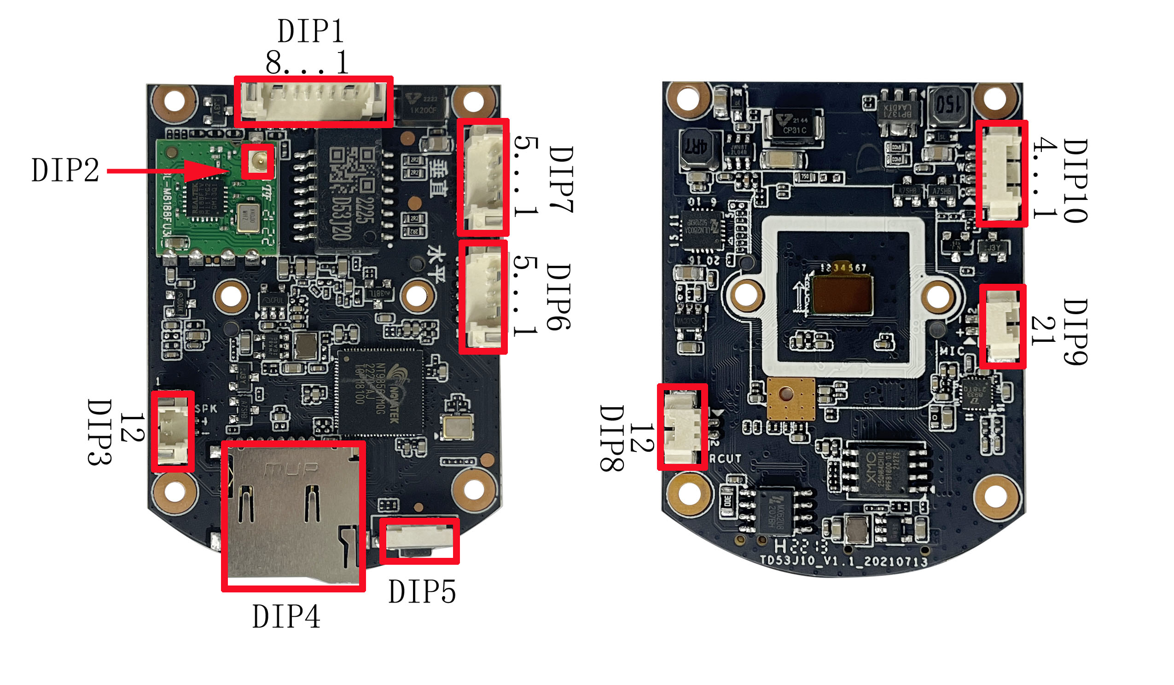

Veneer behind Interface Figure Veneer front Interface Figure

1.2 Pin Definition of TD53J20 Interface Board’s Functional Interfaces
DIP1：Power input and network interface
1 | DC12V
2 | GND
3 | Rx-
4 | Rx+
5 | Tx-
6 | Tx+
7 | RST
8 | ACT

DIP2：WIFI antenna interface
Connect the WIFI antenna

DIP3：Audio output interface
Recommended horn 8Ω/2W
1 | Speaker positive
2 | Speaker Negative

DIP4：T-flash card Socket
flash card Socket

DIP5：Reset key
Support Plate end reset

DIP6：Vertical motor control interface
1 | 4phase
2 | 3phase
3 | 2phase
4 | 1phase
5 | 12V

DIP7：Horizontal motor control interface
1 | 4phase
2 | 3phase
3 | 2phase
4 | 1phase
5 | 12V

DIP8：IR-CUT Interface
1 | IR-CUT connection port 1
2 | IR-CUT connection port 2

DIP9：Audio input interface
1 | Audio input signal
2 | GND

DIP10：light board control signal input and output interface
1 | Alarm IO
2 | Positive pole of Infrared light lamp
3 | Positive pole of white light lamp
4 | Infrared / white anode

2. Appendix: Basic Connection

2.1 DIP1 Power Port
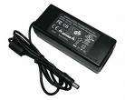
12V
GND
12V/2A

Power Supply
1
DIP1
2

2.2 DIP1 Network Interface
Example 1: Method of directly connect to network cable



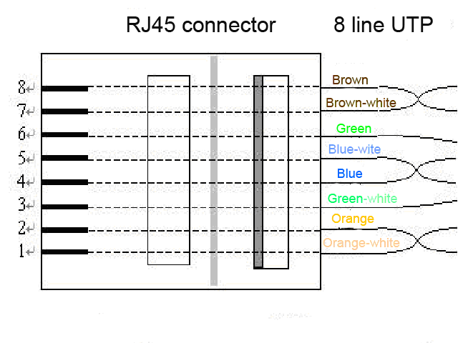
Green-white
Pick-up RST Reset Button
3 4 5 6 7 8
Orange
Orange-white
Green
6
3
1
2
GND

Example 2: Lead up to an RJ45 seat, then use the method of cross-wire and PC connection
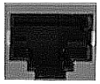
1.TX+
2.TX-
3.RX+
4.NU
5.NU
6.RX-
7.NU
8.NU
RJ45 Pin
3 4 5 6 7 8
DIP2
Cross line

2.3 DIP10 light board control signal input and output interface
1

2

3

4
Alarm IO

Positive pole of Infrared light lamp

Positive pole of white light lamp

Infrared / white anode

2.4 DIP6/DIP7 Motor Interface
Horizontal/Vertical motor specifications
Serial number | Project | Specifications
1 | Voltage | 12 V DC
2 | Number of phases | 4
3 | Slowdown ratio | 1:25.4359

